**Configuring RIP Version 2 (RIPv2) in Cisco Packet Tracer**

This document explains how to configure RIP Version 2 (RIPv2) in Cisco Packet Tracer and provides detailed steps and explanations for setting up the network.

**1. Brief Overview of the Lab Objectives**

The primary objectives of this lab are:

* To configure RIP version 2 (RIPv2) on multiple routers to enable dynamic routing.
* To establish network connectivity and ensure proper communication between different networks.
* To verify RIP configuration by checking routing tables and testing network connectivity using ping.

**2. Steps Taken to Set Up the Network**

**Step 1: Create the Network Topology**

* Use routers, switches, and end devices (PCs) in Packet Tracer to design the network.
* Connect the devices using appropriate cables.

**Step 2: Configure IP Addresses on Routers**

* Assign IP addresses to the router interfaces corresponding to the connected networks.

**Step 3: Enable RIPv2**

* Follow the steps mentioned above to enable RIPv2 and add network statements.

**Step 4: Test Network Connectivity**

* Use the ping command from one network to another to ensure they are communicating properly.

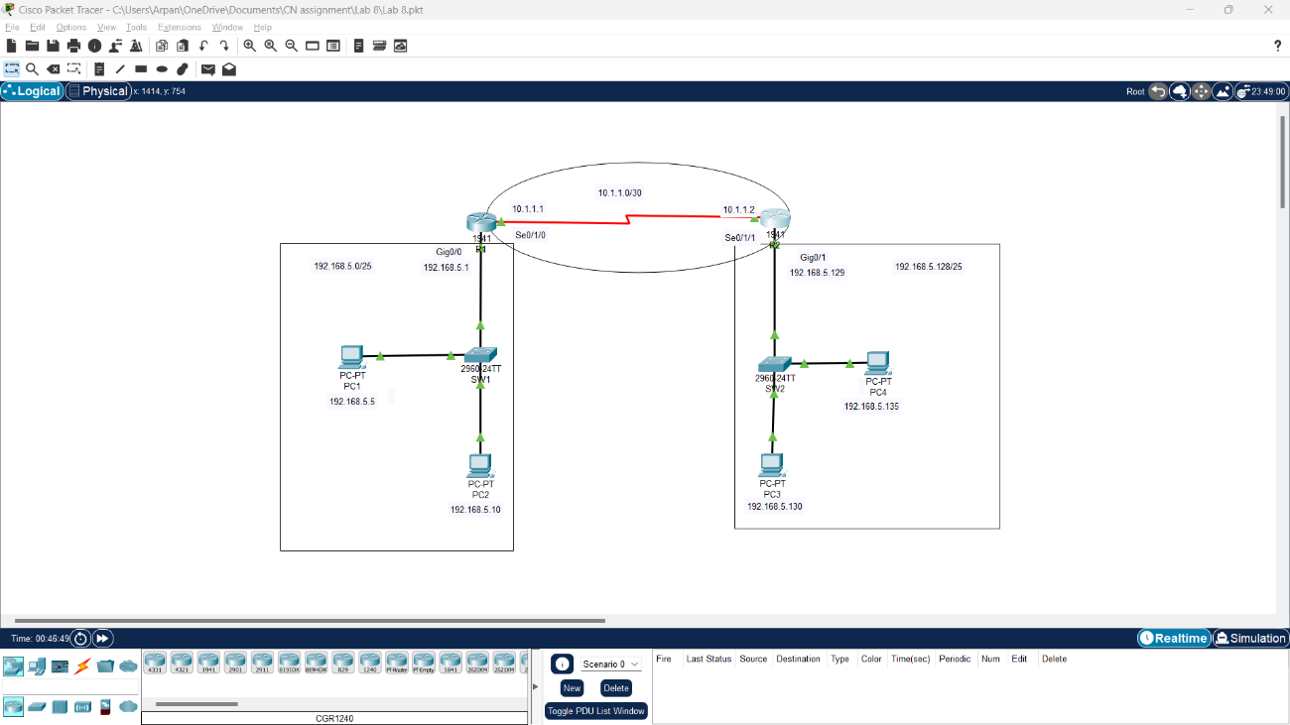

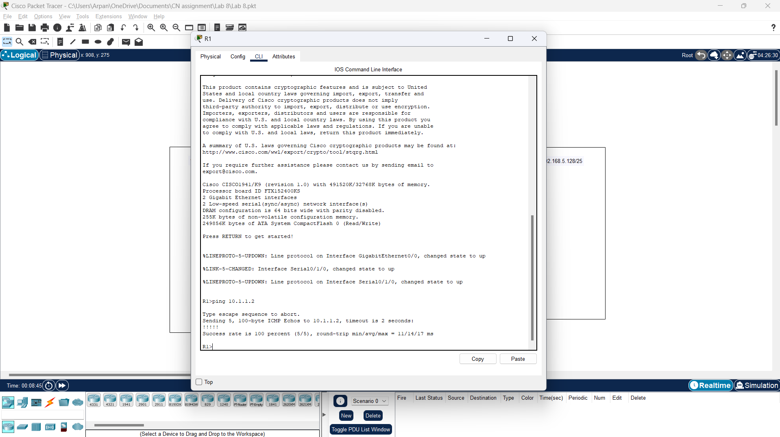

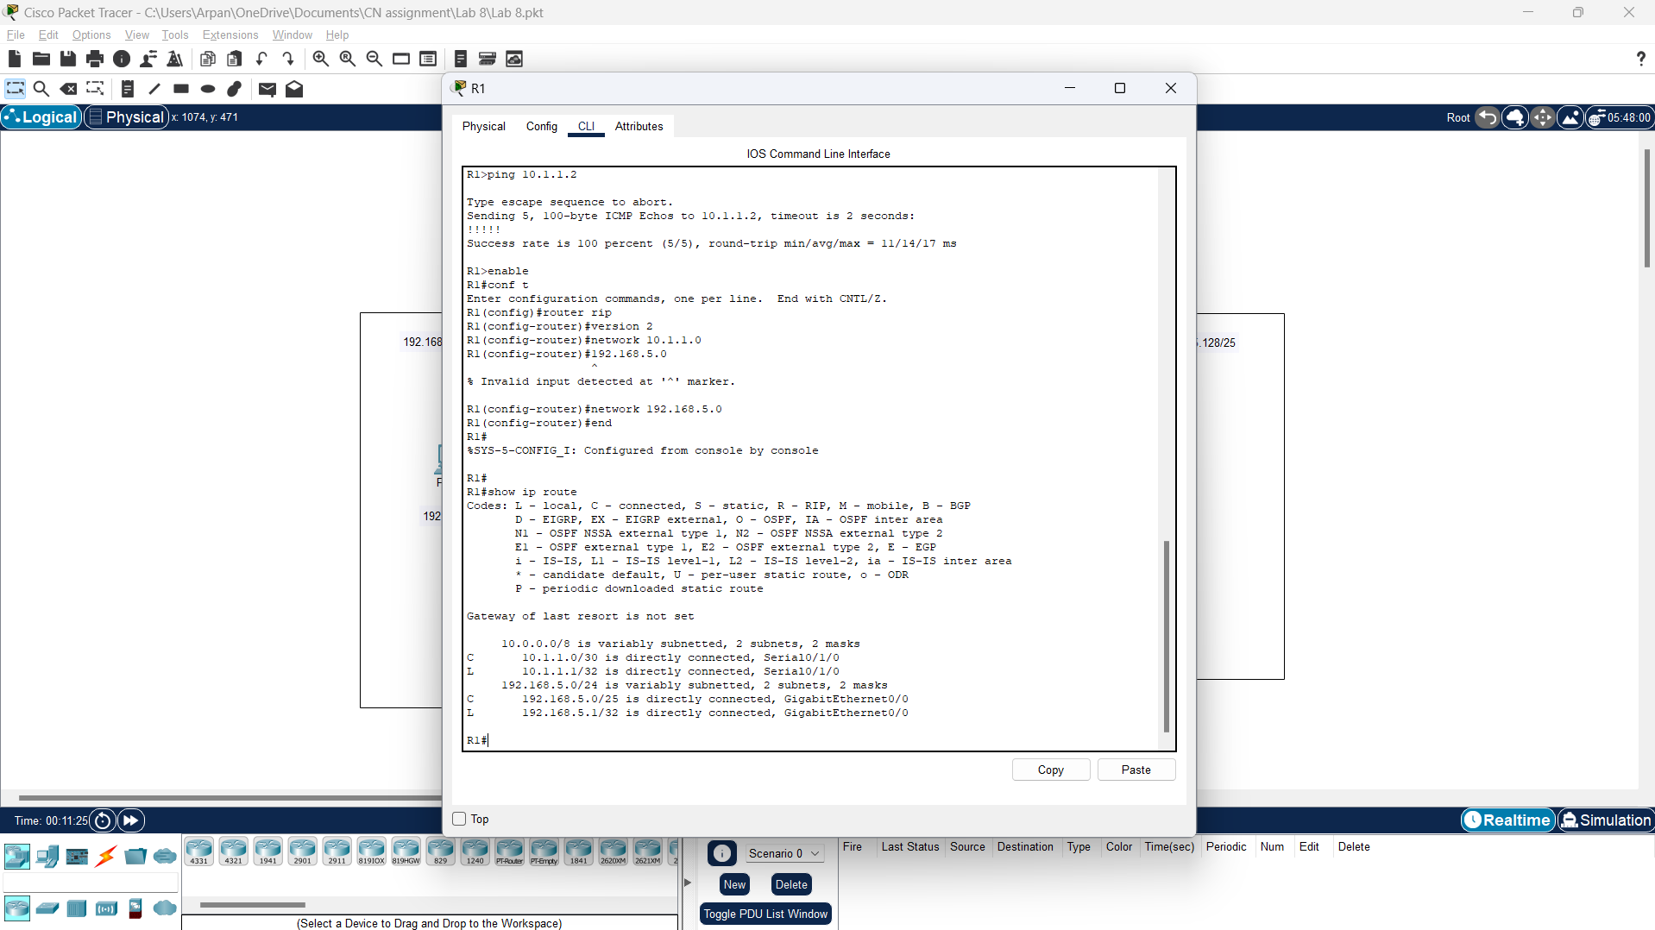

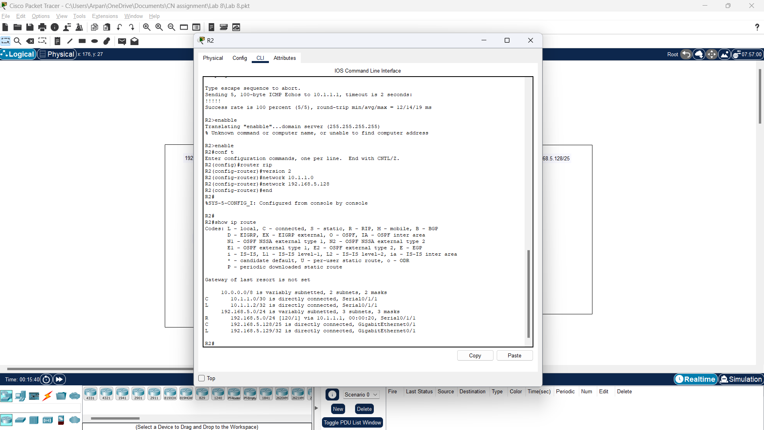

**3. Detailed Information on Cables and Colour Codes**

In Packet Tracer, there are different types of cables used to connect devices. Here’s a brief overview:

* **Copper Straight-Through Cable** (Green colour):
  + Used to connect devices like PCs to switches or routers to switches.
* **Copper Cross-Over Cable** (Yellow colour):
  + Used to connect similar devices, such as router to router, or switch to switch.
* **Fiber Optic Cable** (Orange or Aqua colour):
  + Used for long-distance connections between devices.
* **Console Cable** (Light Blue colour):
  + Used to connect a computer directly to a router or switch for management purposes.